Proof of Signed APK

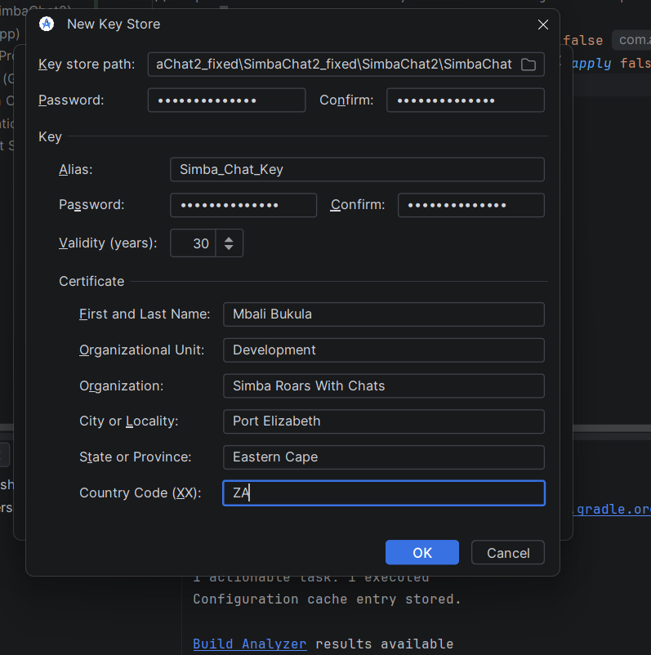
Figure 1Creating the key
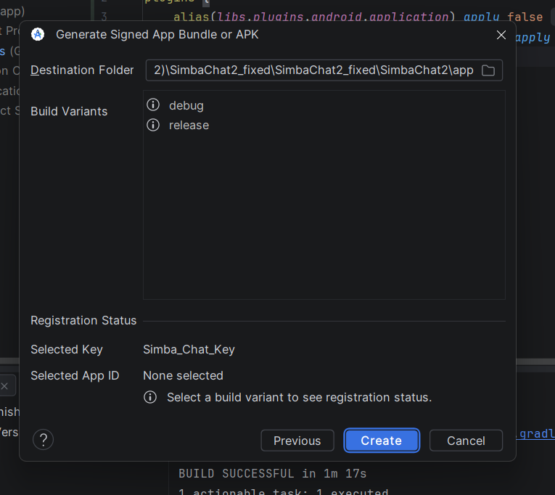

Figure 2selecting the option release

